Chapter 9, Solution 8.

- 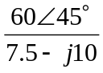+ j2 = 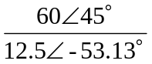+ j2
= 4.898.13 + j2 = –0.6788+j4.752+j2
= –0.6788 + j6.752

- (6–j8)(4+j2) = 24–j32+j12+16 = 40–j20 = 44.72∠–26.57˚
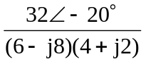+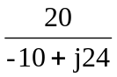 = 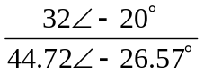+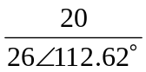

= 0.7156∠6.57˚+0.7692∠–112.62˚ = 0.7109+j0.08188–0.2958–j0.71

= 0.4151–j0.6281

- 20 + (16–50)(1367.38) = 20+20817.38 = 20 + 198.5+j62.13

= 218.5+j62.13

